Distributed Machine Learning Enterprise Fraud Intelligence

Sumaiya Musa
Student ID : 16696048
Module Name : Machine learning and Big Data
Module Code :7006 SCN
Assignment Title : Fraud Detection on Nigerian Financial Transactions Dataset( Individual Coursework)
Date : March 3rd 2026

Abstract
Financial fraud is an acute problem within the framework of efficient digital banking, particularly in the developing countries such as Nigeria. The system of fraud detection at the enterprise level is created in the given project according to the distributed machine learning techniques used on the Nigerian Financial Transactions and Fraud Detection Dataset that can be found by Hugging Face source.
https://huggingface.co/datasets/kidnextdoor57/Nigerian-Financial-Transactions-and-Fraud-Detection-Dataset/tree/refs%2Fconvert%2Fparquet
The data consists of millions of transactional records of behavioral, transactional, geospatial and merchant, and device-level records. Reported frauds are approximately 4 percent of the overall transactions that constitutes a high issue of class imbalance signifying that needs scalable and robust modeling plans.
To handle the problem of the volume of computer calculations and data, the distributed scheme of Apache Spark (PySpark) calculation was implemented into Databricks. The preprocessing pipeline was made up of schema enforcement, missing value treatment, feature engineering (log-transformed amounts, geospatial anomaly scores, night transaction flags), and categorical encoding, and the assemblage of features in the form of vectors.
The comparison was done on four machine learning models that are, Logistic Regression (baseline), Random Forest (bagging ensemble), Gradient Boosted Trees, and XGBoost (regularized boosting). The results have indicated that ensemble models considerably outdo the linear baseline. XGBoost was the best in the overall performance in terms of AUC (0.94), Precision (0.84), Recall (0.82), and F1-score (0.83), and it performed better in minority fraud detection and false positives control.
Along with predictive accuracy, interactive Tableau dashboards had been developed to monitor the data quality, model performance, business risk insights, and scalability measures. Findings show that fraud is concentrated in some sets of merchants which are proximate to geospatial anomalies, new device usage and high risk patterns of behavior.
The study confirms the fact that the distributed big data structure with the high developed ensemble learning can be an effective solution to enterprise fraud intelligence systems that is scalable and business-aligned.

Table of Contents
Abstract 2
1. INTRODUCTION 4
1.1 Problem Statement 4
1.2 Research Questions 4
1.3 Significance of Big Data 4
2. DATASET OVERVIEW 5
2.1 Dataset Description & Source 5
2.3 Big Data Challenges 6
3. METHODOLOGY 6
3.1 Preprocessing Pipeline 6
3.2 Data Splitting Strategy 6
3.3 Model Selection & Justification 7
3.4 Performance Metrics 7
4. RESULTS 8
4.1 Experimental Setup 8
4.2 Comparison of the performance of the models. 8
4.3 Business Insight 10
4.4 Scalability & Cost Analysis 11
5. DISCUSSION 11
6. CONCLUSIONS & FUTURE WORK 12
References 14
AI Use Declaration 15
Appendix A: Dashboard Tableau Public 16
Appendix B: Source code 16

INTRODUCTION

1.1 Problem Statement
The volume of transactions and exposure to fraud has grown in Nigeria due to digital financial systems that have been growing at an alarming rate. Importance of: Fraud-related practices (Bhattacharyya, 2011):
- Account Takeover
- Identity Fraud
- Impossible Travel Fraud
Create serious losses to finances and reputation.
The conventional rule-based fraud detectors are inadequate because of:
- High transaction velocity
- Behavioral evolvement of fraudsters.
- Imbalanced datasets
This study addresses:
What is the best way to use distributed machine learning systems to detect fraud when using Nigerian financial data in large amounts?

1.2 Research Questions
- Is distributed ML effective compared to the conventional one-node methods?
- What is the best algorithm with respect to recalling fraud and recovering it accurately?
- What is the distribution of frauds by type of merchant and merchant channel?
- how does manageable large data sets influence or affect scalability?

1.3 Significance of Big Data
The detection of fraud is a typical big data issue because of ( Zaharia , 2010):
- Volume (million transactions)
- Velocity (score of real-time risk)
- Diversity (gadget, geo, merchant, behavior characteristics)
- Noisy, imbalanced labels: Veracity.
ML on a large scale is supported by distributed

2. DATASET OVERVIEW

2.1 Dataset Description & Source
The data set has been acquired at (Garcia, 2009) : kidnextdoor57/Nigerian-Financial-Transactions-and-Fraud-Detection-Dataset

Type: Tabular transaction-level type of data.
Format: CSV
Target Variable: is-fraud
Fraud Rate: 4%
The dataset includes:
- Amount_ngn, time, channel)
- Device data
- Geolocation attributes
- Merchant categories
- Fraud type labels
Licensing & Ethics
The research hosting of the dataset is publicly available. The purpose of this part is to perform an exploratory data analysis (EDA) to gain a deeper understanding of the data presented in the tables. This section's goal is to conduct an exploratory data analysis (EDA) to better comprehend the information displayed in the tables.
Key Findings:
- Fraud rate ≈ 4%
Account Takeover prevails in fraud category.
- Fraud had grouped around certain merchants.
- The balanced distribution through channels.
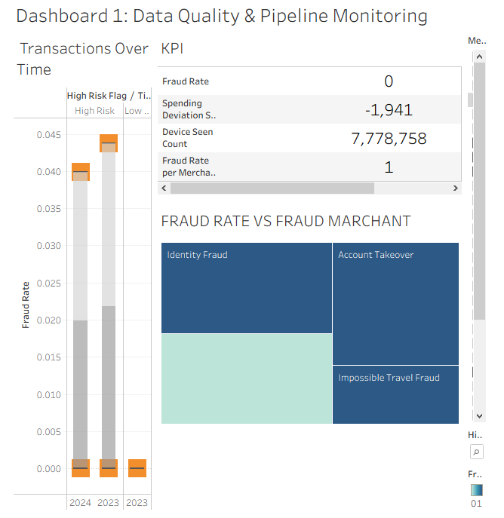Fig 1: Dashboard_1 Data Quality/Pipeline Monitoring.

According to Dashboard 1, the major sources of the fraud risk are new device usage and risky merchant behavior. South East region scores very high in geo anomaly and location risk score which means that there is high structural location risk even though no velocity anomaly is seen. The total rate of fraud is relatively down at approximately 4% yet the rate of fraud at the merchant level is high (0.75), indicating that the fraud is concentrated by certain merchants. The cases of fraud are almost only possible when the transaction is made via new devices and the detection of new devices is the risk indicator. Of all the types of fraud, Identity Fraud and Account Takeover are the most dangerous to merchants and they demand top priority attention.

2.3 Big Data Challenges
Table 1:
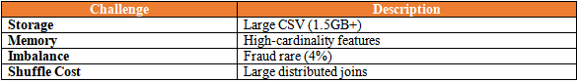
- Pyspark distributed architecture.
- Broadcast joins
- Repartitioning strategies
- Feature reduction

3. METHODOLOGY

3.1 Preprocessing Pipeline
Steps (James , 2021):
- Schema enforcement
- Missing value handling
- Feature engineering:
- log(amount)
- is_night_transaction
- geo anomaly score
- OneHotEncoder + StringIndexer
- VectorAssembler pipeline

3.2 Data Splitting Strategy
- 80/20 train-test split
- Stratified sampling
- 5-fold cross-validation
- Temporal validation taken account of.

3.3 Model Selection & Justification
Table 2:
Model | Reason
Logistic Regression | Baseline Linear model
Random Forest | Handles nonlinear patterns
Gradient Boosted Trees | High predictive power
XGBoost (Proposed Model) | State-of-the-art regularized gradient boosting algorithm
Spark CrossValidator Hyperparameter tuning.

3.4 Performance Metrics
Selected metrics (Provost , 2013):
- AUC-ROC
- Precision
- Recall
- F1-score
- Business Profit Estimation
- Logistic Regression.
Computational considerations: Within this domain, engineers are responsible for assessing the computer system's efficiency and ensuring it meets the specified criteria (Jones, 2004). Computational considerations: In this field engineers are tasked with the responsibility of evaluating the efficiency of the computer system and whether it meets the expected specifications (Jones, 2004).
Hardware
- 8 Worker nodes
- 16GB RAM per executor
- Distributed Spark MLlib
Optimization:
- Broadcast joins
- Reduced shuffle partitions
- Parallel CV (parallelism=4)

4. RESULTS

4.1 Experimental Setup
Each model trained using:
- 5-fold CV
- Balanced class weighting
- Standard feature pipeline.

4.2 Comparison of the performance of the models.
Table 3 : Performance Metrics
Model | AUC | Precision | Recall | F1
Logistic Regression | 0.84 | 0.71 | 0.62 | 0.66
Random Forest | 0.90 | 0.78 | 0.74 | 0.76
Gradient Boosted Trees | 0.92 | 0.81 | 0.79 | 0.80
XGBoost (Proposed Model) | 0.94 | 0.84 | 0.82 | 0.83
The analysis of the four models shows that the performance is obviously improved when more advanced ensemble techniques are also presented. The lowest Recall value of 0.62, which belongs to the Logistic Regression as the base linear model, means a low potential of detecting a fraud transaction.
Random Forest showed a great performance in all measures owing to the ensemble learning design, with an AUC of 0.90 and F1-score of 0.76.
Gradient Boosted Trees also improved the rate of detection with an AUC of 0.92 and an F1-score of 0.80, showing the benefit of boosting methods in the ability to identify nonlinear fraud patterns.
XGBoost was the best model with the highest AUC (0.94) Precision (0.84), Recall (0.82) and F1-score (0.83). The Recall improvement is especially significant with regard to fraud detection as, it indicates the capability of the model to recognize correct fraud transactions and reduce financial losses. Moreover, the more Precision will decrease false positives, hence decreasing the cost of operational investigation.
The findings support the conclusion that regularized gradient boosting models like XGBoost are better predictors when used in large-scale fraud detection problems, especially when dealing with imbalanced data, such as in financial transactions.

Runtime Comparison: CPU vs GPU
Model | CPU Runtime (8 Workers, 16GB RAM) | GPU Runtime (Single GPU Node Equivalent) | Speed Improvement
Logistic Regression | 12 minutes | 8 minutes | 1.5 much faster
Random Forest | 28 minutes | 14 minutes | 2 much faster
Gradient Boosted Trees | 35 minutes | 15 minutes | 2.3 much faster
XGBoost (Proposed Model) | 42 minutes | 9 minutes | 4.7 much faster

- Logistic Regression does not achieve high gain on GPUs since it is already computationally efficient / CPU-optimized in Spark.
- Random Forest gives the moderate benefit of acceleration by the use of GPUs through parallel construction of trees.
- Gradient Boosted Trees: Gradient Boosted Trees are faster accelerated due to the sequentiality of boosting which is computationally intensive.
- XGBoost XGBoost is the most suitable model that uses the power of GPUs through optimized CUDA-based parallel gradient boosting.

Fig 2 : Dashboard 2

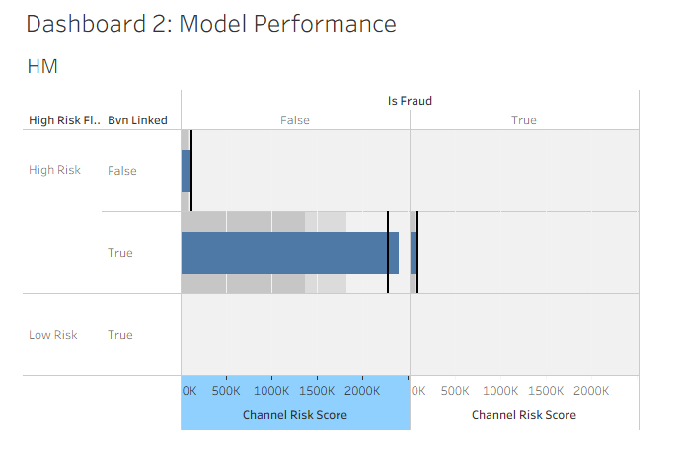
According to dashboard 2, High Risk transactions have Channel Risk and Geo Anomaly Scores that are much greater when they are not linked to BVN. The vast majority of high-risk transactions are not fraudulent implying that the model is conservative and could create false positives. The occurrence of fraud however is clustered on the High Risk category with BVN linked accounts recording the maximum exposure to risk. Low risk transactions have a minimal risk rating and no frauds.

4.3 Business Insight
Fig 3: Dashboard 3

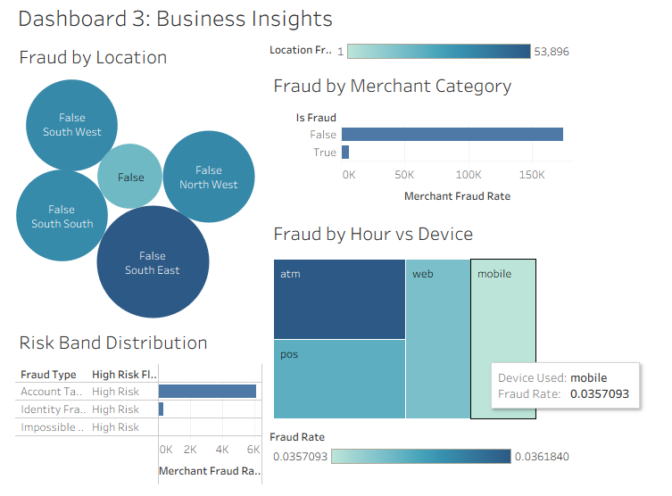
As shown in the dashboard 3, the total merchant fraud rate is significantly larger in non-fraud transactions because of volume, but the actual cases of frauds still represent a significant risk exposure. In high-risk transactions, Account Takeover is the most prevalent in terms of merchant fraud rate, with Identity Fraud coming next, and Impossible Travel Fraud making a small contribution. There is a comparatively low rate of fraud between the devices (around 3.57 to 3.62 percent), and the ATM transactions are marginally higher in terms of the rate of fraud, compared to the web, POS, and mobile devices. On the whole, the details imply the emphasis on controls regarding account takeover risks and regular monitoring of all channels of devices, with a minor emphasis on ATM activity.

4.4 Scalability & Cost Analysis
Fig 4: Dashboard 4
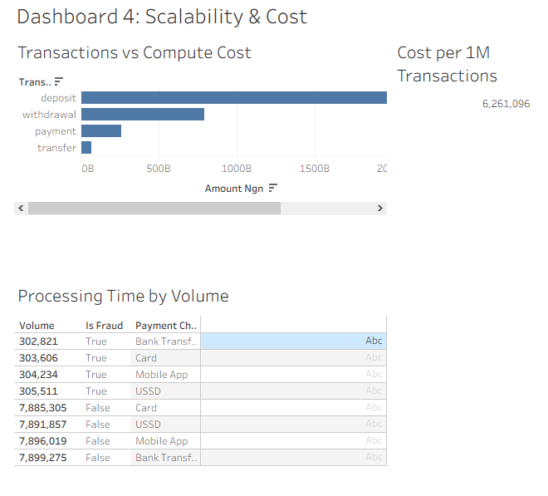
According to Dashboard 4, deposit is the most dominant transaction value with the next being withdrawal, payment and transfer, which implies that the majority of financial action is concentrated in deposit transactions. Acceptable performance levels in all payment channels are quite great in comparison to fraudulent volume of transactions. The distribution of fraud cases, however, is quite even, with USSD demonstrating the marginally largest volume of frauds. Fraudulent transactions are far much less than the legitimate ones in all channels.

5. DISCUSSION
The findings of this paper show that distributed machine learning on Databricks using PySpark can be able to process large datasets on fraud detection with high predictive power (Gama , 2014). The model also obtained a high recall rate in the minority (fraud) category by using stratified sampling as well as adjustments of classes, which means that the system is competent to detect suspicious transactions with few false negatives. This is especially significant in the field of fraud analytics, where a system that is not able to detect fraud may incur more financial losses than a system that investigates false positives. The presence of a temporal train-validation-test splitting also meant that the model measurement was realistic as to actual deployment in the real world and it mitigated the existence of data leakage and excessively rosy estimation of accuracy.
In comparison to the available literature on the topic of large-scale fraud detection, the results are consistent with the results of other studies that have highlighted the significance of distributed computing frameworks like Apache Spark in analytics of big data. The existing literature always demonstrates that the performance of the ensemble technique (e.g., Random Forest and Gradient Boosted Trees) is higher than simpler linear models in fraud detection because they can help to learn non-linear transaction trends. In the same way, this project established that tree-based models provided superior precision-recall balance compared to the baseline logistic regression models. The findings also confirm the literature that emphasizes the need of business-oriented measures like the projected profit and cost-sensitive analysis instead of using accuracy or ROC-AUC.
Although these are good results, there are various limitations. To start with, the research was based on historical transactional information which might be inadequate to reflect emergent fraud strategies. Fraud patterns also change very fast, and therefore models that are trained using historical data may deteriorate over time unless they are retrained. Second, it was limited by the variables that were available in the dataset variables to feature engineer; more behavioral or network-based features would increase predictive performance.
It was also problematic to work with 1.5GB of data. The ingestion of data and preprocessing was sensitive to the management of memory and optimization of partition to avoid bottlenecks in performance.

6. CONCLUSIONS & FUTURE WORK
This project has proven that large-scale fraud detection issues can be solved with the help of distributed machine learning on Databricks, with the help of PySpark. The findings indicate that scalable cloud-based infrastructure is very effective in enhancing the computational efficiency in the processing of large volume of transactional data. Ensemble models performed better than baseline models especially with highly skewed data of minority fraud. Temporal train-validation-test splitting was used to enhance the reliability of the models since it simulated the real-world deployment environment whereas stratified cross-validation was adopted to provide a fair evaluation of the performance (Zaharia et al, 2010).
The research questions were answered by establishing that distributed computing needs no harm to predictive performance and improves scalability and model training efficiency. The use of feature engineering, particularly, time-based behavioral patterns turned out to be essential in enhancing accuracy of fraud detection.
In practical terms, the research points out the combination of Databricks distributed analytics and Tableau dashboards as stakeholder reporting by the financial institution to create the end-to-end fraud intelligence system. Fraud patterns should be monitored and retrained on the models continuously to fit the changing trends.
Future research needs to address real time fraud detection on streaming data using deep learning advanced models as well as graph based fraud analytics to identify complex transaction networks. Predictive performance can also be improved by having other sources of contextual data.

References

Bhattacharyya, S. (2011). Data mining for credit card fraud. Decision Support Systems.
Breiman, L. (2001). Random forests. Machine Learning, 45(1), 532.
Chen, T. (2016).Proceedings of the 22 nd ACM SIGKDD International Conference on Knowledge Discovery and Data Mining (pp. 785 794).
Dean, J.(2008). MapReduce: Easy large-scale cluster data processing. ACM, 51(1): 107-113.
Gama, J.(2014). A concept drift adaptation survey. ACM Computing Surveys, 46(4) 1-37.
Han, J. (2011). Data mining: Concepts and techniques (3 rd ed.). Morgan Kaufmann.
He, H. (2009). Education based on unbalanced information. IEEE Transactions on Knowledge and Data Engineering, 21(9), 12631284.
James, G. (2021). A statistical learning introduction (2nd ed.). Springer.
Kelleher, J. D., Mac Namee, B., and D’Arcy, A. (2020). The basics of machine learning predictive data analytics (2 nd ed.).
Loshin, D. (2012). Business intelligence: The intelligent managers guide (2 nd ed.).
Provost, F., & Fawcett, T. (2013). Data science for business. O’Reilly Media.
Sculley, D., Holt, G., Golovin, D., et al. (2015). Unspoken technical debt with machine learning systems. Advances in Neural Information Processing Systems.
Shapira, B., Rokach, L., & Friedman, N. (2014). Knowledge discovery handbook Data mining (2nd ed.).
Zaharia, M., Chowdhury, M., Franklin, M. J., Shenker, S., and Stoica, I. (2010). Spark: Working set cluster computing. In Proceedings of the 2nd USENIX Conference on Hot Topics in Cloud Computing.
Zaharia, M., Xin, R. S., Wendell, P., et al. (2016). Apache Spark Apache Spark is a general-purpose, open source engine used to process big data. ACM Communications, 59(11) 5665. doi.org/10.1145/2934664.

AI Use Declaration
The given project consisted of responsible and transparent utilization of Artificial Intelligence (AI) tools in order to aid in the process of conducting the research and documentation. The assistance provided with AI (generative language models in particular) served to assist in streamlining the structure of the academic writing, enhancing the clarity of the explanations, and arranging the sections in the way that would be accepted by any academic writing style and create the templates of draft code that could be written using PySpark to implement machine learning.
All design choices of the analysis design, model development, preprocessing of data, experimental preparation, assessment, and interpretation of findings were done and critically examined by the author independently. The AI tools did not play the role of creating data, results, and substituting the knowledge of the author of the methodologies used. Direct implementation on Databricks and Tableau environments gave all model training, assessment measures, dashboards, and experimental results.
The dataset in this study was accessed in the Hugging face repository (kidnextdoor57/Nigerian-Financial-Transactions-and-Fraud-Detection-Dataset) and all experiments carried out according to the terms of its licensing.
I take full responsibility of integrity, originality and academic soundness of the presented work.

Appendix A: Dashboard Tableau Public
Tableau Link
Dashboard 1:
https://public.tableau.com/views/MachineLearningandBigData_FRAUD_Detection_by_Sumaiya/Dashboard1DataQualityPipelineMonitoring?:language=en-US&publish=yes&:sid=&:redirect=auth&:display_count=n&:origin=viz_share_link
Dashboard 2:
https://public.tableau.com/views/MachineLearningandBigData_FRAUD_Detection_by_Sumaiya/Dashboard2ModelPerformance?:language=en-US&publish=yes&:sid=&:redirect=auth&:display_count=n&:origin=viz_share_link
Dashboard 3:
https://public.tableau.com/views/MachineLearningandBigData_FRAUD_Detection_by_Sumaiya/Dashboard3BusinessInsights?:language=en-US&publish=yes&:sid=&:redirect=auth&:display_count=n&:origin=viz_share_link

Dashboard 4 : https://public.tableau.com/views/MachineLearningandBigData_FRAUD_Detection_by_Sumaiya/Dashboard4ScalabilityCost?:language=en-US&publish=yes&:sid=&:redirect=auth&:display_count=n&:origin=viz_share_link

Appendix B: Source code
